ALSB ATTENDEE AND PRESENTER GUIDE
Academic Breakout Sessions
(Use this list if you are preseting a paper or attending a session.)

Welcome to the 2020 Conference! We are excited to offer this conference in an online format. Because online is quite different from in-person, please review this checklist to help your experience be smooth and to avoid certain common problems.

- INITIAL ITEMS:
  - In order to fully participate in the conference, all attendees are expected to be familiar with their computer and video conferencing tools. We will use WebEx for most academic sessions and Zoom for most social events. This includes knowing how to join meetings, manage and troubleshoot audio and video, use chat functions, mute and unmute one’s microphone, and share content. A number of links are provided below to help navigate these conferencing tools.

  - Although limited tech support resources will be available, we cannot guarantee one-on-one technical assistance for every attendee. Please resolve any technological issues or questions before the conference begins by using online resources or contacting your institution’s information technology support staff. You may wish to conduct a test run with your information technology support staff for both applications before the conference begins. There will also be technology assistance available during the lunch hour in our ‘tech check’ room on a first come, first served basis.

  - All attendees will need a computer with web camera, microphone, and access to the internet. It is a best practice to use a desktop computer with a landline with mute capabilities for best connectivity, sound, and video.

  - Close unneeded background applications and eliminate any simultaneous streaming activities wherever possible in order to reduce internet bandwidth use that could interfere with your connection.

  - If you have your camera turned on, if possible try to avoid a background that is busy or distracting location (like a busy street or hallway), and that you have minimized distractions for the presenters. You may want to have your camera turned off while listening to presentations and then turn it on if you are asking a question.

  - TEST WEBEX AND ZOOM BEFORE JOINING A SESSION: Visit https://help.webex.com/en-us/nti2f6w/Webex-Meetings-Join-a-Test-Meeting for more information about WebEx and test it with your machine at https://www.webex.com/test-meeting.html. Here you can log in to a test session. At this test meeting, you can look at all the icons, turn on and off chat, practice sharing your screen, view a participants list, practice raising your hand, review the different menus, and explore. Zoom has a test room with similar functions at https://zoom.us/test.

  - Plan to arrive at least five minutes early to each session in order to check your video and audio connections and resolve any last-minute problems. Session moderators will be asked to start conference sessions promptly at the appropriate time. Moderators will be focusing on keeping their presenters on track, and will not be able to address technical problems.

- ENTRY:
  - Please use the appropriate link on the conference program schedule that is emailed to you. Links will not be publicly available on the ALSB webpage because access is limited to those who have registered and paid for the conference.

  - Launch the appropriate application. Neither WebEx nor Zoom require separate desktop applications. Clicking on the weblinks is all that is required.

  - For WebEx, you should see a room open with a green bar that says, “Join Meeting.” Click that. Zoom will have a similar prompt.

  - You may need to select your camera and audio connections. If you do not know how to do this, please contact your institution’s information technology support staff prior to the conference.

  - Please sign in with your full name and avoid using “Guest” as your identifier.

- DURING THE MEETING:
  - Please keep yourself muted at all times in order to reduce unwanted noise.

  - Although chat will be available during sessions, please keep chat discussions on-topic to the session at hand.

  - If you have trouble viewing a presenter’s video because of internet bandwidth problems, you may wish to listen to the session with audio only to increase the chance of a clear connection.

  - Please direct questions to presenters either through chat or through the hand-raising function as the moderator instructs. Some presenters may wish to hold questions until the end of their presentation. Notwithstanding technology issues, presenters will have at least 20 minutes to present, including Q&A.

- AT THE END OF THE SESSION:
  - Click “Leave Meeting” when the session ends. To avoid confusion, please do not remain connected to conference sessions that you are not actively attending.

- FOR MORE INFORMATION:
  - Please review the Q&A section as well as the WebEx and Zoom tutorial links provided below.

PLEASE REMEMBER –online conference rooms are like real conference rooms in a hotel. While joining a few minutes early may be helpful for setting up software, if you enter too early, you may be entering during the previous session.

Thanks for reading!

Step-by-Step Instructions

How to Join a WebEx Meeting

For more detailed instructions, click here:
https://help.webex.com/en-us/nrbgeodb/Join-a-Webex-Meeting#id_134856

For further information, see the helpful resources links below.

- Click on the invite link for the session you wish to join. Invite links are available in the conference program next to each session.

- If this is the first time you're joining a Webex meeting, Webex automatically downloads the app. Click the installer file to install the app.

- Enter your full name (first and last) and email address.

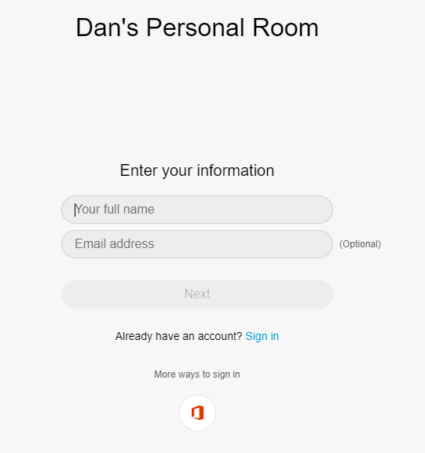

- The ‘Next’ button will turn blue. Click on the ‘Next’ button to proceed to your meeting.

(Continued to the next page)

- You will see a screen like below.

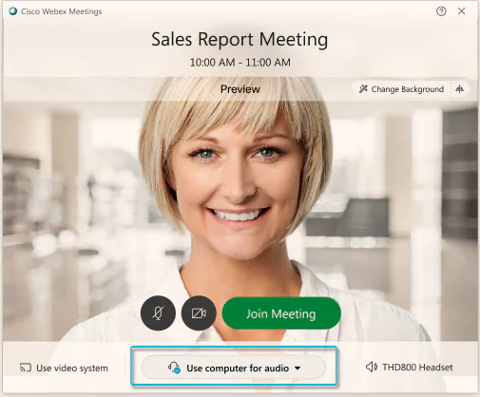

This will allow you to choose which audio type you wish to follow. The default is “use computer for audio” and that is what most people will use. However, you may wish to use your telephone for audio or to not use your audio at all. Click the pulldown menu to select the audio you will need.

At this point, your camera and audio are turned off by default. The video and microphone buttons will be red in color. To turn on your microphone and camera, click the red microphone button and the red camera button.

Then click on the green meeting button to join the session.

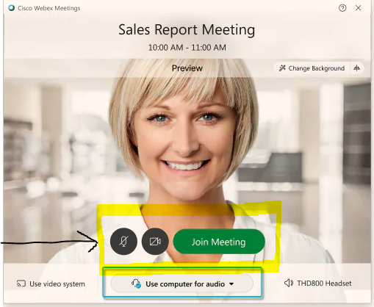

Note to telephone users: When you dial into a meeting via telephone, you can hear everyone in the meeting, but won't be able to see anyone or what they share during the meeting. The phone number to call for all sessions is +1-415-655-0002. Each session will have a phone access code, which will be available on a master sheet of all conference links. Phone access codes will look something like this: 120 563 4568. To access a session via telephone, call the number above, follow the instructions, and input the access code when requested.

How to Share Content

For more detailed instructions, click here:
https://bit.ly/2CMrxT4

In WebEx Meeting, the software used for most conference sessions, anyone in a meeting can share content. When you share your screen, everyone sees what you can see on your screen. If you have a Word document or a PowerPoint slide, or even a website or chat window open, everyone in the session will be able to see it.

To share an application, such as a Word document or a PowerPoint slide:

- Open your desired content.

- Click on the share button, circled below.

- You will see a screen similar to that below. Please choose the application or screen that you wish to share. There is an option available for optimizing motion or video on your screen if necessary.

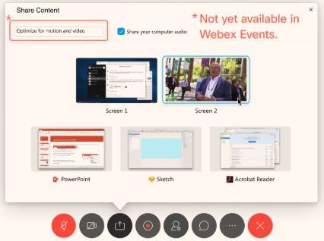

- When you share your screen you will see a small tab at the top of your screen similar to this: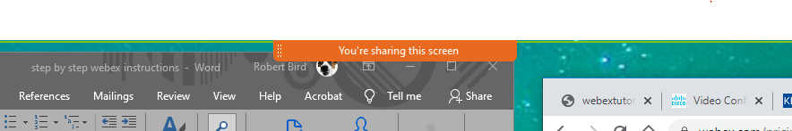

- Move your mouse over the small tab, and the menu will expand to offer features of screen sharing:

- To stop sharing, click on the ‘Stop Sharing’ button on the left of the expanded menu. In order to avoid showing private information, please stop sharing your screen just as you are done. You will also need to stop sharing in order to allow the next presenter or anyone else to share their content.

Q&A

Technology Questions

Q: What conference tools will be used during the conference?

WebEx Meeting will be used for almost all academic conference sessions. WebEx Events, which is similar to WebEx Meeting but has some different functions, will be used for major conference events. Zoom will be used for almost all non-academic and social events, such as the icebreaker and business meeting.

Q: What technical assistance is available to me?

Each attendee is responsible for familiarizing themselves with their computer and WebEx. Limited information technology assistance for WebEx Meetings may be available during academic conference sessions from UConn IT staff. There will also be daily ‘tech checks’ during the lunch hour period where attendees can get assistance on a first-come, first-served basis. During WebEx Events, IT staff will be focusing on the event and be unavailable for technology assistance.

Please note that one-on-one assistance is not guaranteed. Please practice with WebEx or Zoom ahead of time (links for test rooms are available below) and resolve any questions with your school’s information technology staff.

Q: I have a problem with my connection. What should I do first?

As a first step, please restart your computer and restart your Zoom or Webex applications. Many problems can be resolved this way.

Q: I can’t see the presenter or the PowerPoint. What can I do?

A common problem is that the presentation view needs to be changed. In the upper right corner of your screen you should see three icons that will change the view. You can select the presenter view from those icons to enlarge the presentation.

Q: Can I share my screen?

You are able to share your screen in WebEx Meeting. However, please do not do so unless you are actively presenting. That would be the same as walking to the front of the room during a presentation and taking over the presentation. Information on how to share content is available in the links below.

Q: Is a polling feature available in WebEx Meeting?

Polling is available, but we recommend against using this feature unless you are fully comfortable with using the polling function, teaching it to your attendees on the spot, and are willing to use limited presentation time to conduct a poll. For simple yes/no responses, an easier way to poll the audience is to use the hand-raising function in WebEx Meeting. More information about polling is available in the links below.

Q: Can I record conference sessions for later use or public distribution?

In order to encourage free and open dialogue, please do not record any conference sessions. Not all attendees and presenters will be comfortable with recordings.

Q: Will breakout rooms be available in WebEx sessions?

No. In order to keep sessions running smoothly, breakout rooms will not be available in conference sessions. Asking attendees to enter and leave breakout sessions takes longer than the presenter usually anticipates and can sometimes not work properly. WebEx Meeting also does not fully support breakout sessions. Breakout sessions may be available during Zoom events.

Q: Do I need to use a virtual background?

The choice of using a virtual background is up to each attendee. A virtual background is recommended if what is going on behind you may be a source of distraction. See the links below for further information.

Q: Where can I learn more about how to use WebEx and Zoom?

A number of articles and videos are available below to help users understand the basic functions of WebEx. There are also a number of third-party articles and YouTube videos that may also be useful.

Q: I see at the conference we will be using WebEx Meeting and WebEx Events. What is the difference?

WebEx Meeting will be used for most breakout sessions and is designed to give the greatest flexibility to all attendees to participate. Attendees in WebEx Meeting have greater control over their video, audio, and what they can share. This allows for maximum flexibility in sessions, but also relies on the honor system that all conference attendees will be well-prepared to use WebEx in a manner that is not disruptive to others. WebEx Events delivers a more curated experience with most functions resting with the panelists and the moderator. A link showing detailed differences between the two is listed below.

Presentation Questions

Q: I am a presenter. Will the moderator pass the moderating functions to me when I present my paper so I can share my PowerPoint?

WebEx Meeting allows any attendee or presenter in the meeting to share their content at any time, including PowerPoint slides. The moderator does not need to pass control to presenters beforehand. To learn more about how to share content during a presentation, please review the links below.

Q: Does the second sharer of content have to wait until the first sharer has stopped sharing their content?

Yes. A presenter who is presenting content is responsible for both sharing their content appropriately and ending that sharing function when they are finished. This is another reason why each attendee will need to familiarize yourself fully with the functions of WebEx before the conference begins.

Q: Will a moderator be able to mute participants?

Moderators do not have independent power to mute participants, but can do so by contacting the information technology support person available, also known as the HOST, for the session.

Q: How much time will a presenter have to present their paper in an academic session or development track?

Most academic and development track sessions are one hour and forty-five minutes long. These sessions are longer than in the past for two reasons: 1) to give ample time to resolve technical problems, and 2) to encourage helpful feedback and dialogue between the presenter and her audience.

How much time is available to each presenter will vary according to the number of presenters and the presence of technical problems. Time divisions will be at the discretion of the moderator. Each presenter should expect to have a minimum of 20 minutes of presentation time, and quite possibly more as time allows.

Q: Whose responsibility is it to keep time during conference presentations? What role will the moderator have?

The responsibility of keeping time rests primarily with the presenter. However, similar to past conferences, the moderator will provide warnings, either orally or through the chat function, when presentation time is running out. When the presenter’s time has expired, the moderator will orally request the presenter to end their presentation.

Q: Do you recommend that only presenters and moderators show their camera, with attendees not on video unless asking questions?

The choice is up to you. Presenters may feel more comfortable presenting to faces than blank screens. Attendees showing their video will not interfere with the session. However, attendees who do not mute their audio will interfere with the session, so it is important to ensure that audio is muted whenever possible.

Q: I am a presenter on the Development Track. How can I make my paper available to participants?

You can send the development track papers to Shelly (sjmoore@umich.edu) and she will get the papers posted to the Member’s Only site where the academic session papers are posted.

Other Questions

Q: Where can I get copies of papers in the Academic Sessions?

Papers will be in the Members Only section of the ALSB website.

Q: Where can I get the CLE Forms?

The CLE form and instructions are posted to the conference website. Also feel free to reach out directly to Shelly (sjmoore@umich.edu).
HELPFUL RESOURCE

Please review the following resources if you are not fully familiar with WebEx or Zoom.

Testing Your Camera and Microphone in WebEx or Zoom

WebEx: https://www.webex.com/test-meeting.html
Zoom: https://zoom.us/test

Joining and Using WebEx Meeting

Getting Started: https://help.webex.com/en-us/n62wi3c/Get-Started-with-Cisco-Webex-Meetings-for-Attendees
Webex System Requirements: https://help.webex.com/en-us/nki3xrq/Webex-Meetings-Suite-System-Requirements
How to join a Webex meeting: https://help.webex.com/en-us/nrbgeodb/Join-a-Webex-Meeting
How to share content: https://help.webex.com/en-us/5ddww5/Share-Content-in-Cisco-Webex-Meetings-and-Cisco-Webex-Events
Connecting with audio and video: https://help.webex.com/en-us/cjr7xq/Connect-to-Audio-and-Video-in-Cisco-Webex-Meetings
Common troubleshooting problems: https://help.webex.com/en-us/WBX9000018881/Troubleshooting-Meetings
Best Practices: https://www.webex.com/content/dam/webex/eopi/assets/WebexMeetings_BestPractices.pdf
How to start a poll: https://help.webex.com/en-us/n0pdj9x/Start-a-Poll-in-Cisco-Webex-Meetings
Virtual backgrounds: https://help.webex.com/en-us/80jduab/Use-a-Virtual-Background-in-Webex-Meetings-Events-and-Training
Summary of differences between WebEx Meeting and WebEx Events: https://help.webex.com/en-us/WBX40116/What-are-the-Differences-Between-Webex-Meetings-and-Events
Master list of Webex help pages: https://help.webex.com/ld-nyw95a4-CiscoWebexMeetings/Webex-Meetings#Get-Started

WebEx Video Guides

List of Webex video guides: https://www.youtube.com/playlist?list=PL_YnWo4XhzTfhkcwB6M1a-wJ9dTlz58yz
How to join a meeting (2:34): https://youtu.be/ru85544RveA
How to focus on a single person (1:50): https://youtu.be/P7EGn9C3nuA
How to share content (1:55): https://youtu.be/CexaPP0HtSA
How to change video layout (1:37): https://youtu.be/sO65MExXnmY

Joining a Meeting in Zoom

Quick start guide for new Zoom users: https://support.zoom.us/hc/en-us/articles/360034967471-Quick-start-guide-for-new-users
Testing Zoom video: https://support.zoom.us/hc/en-us/articles/201362313-How-Do-I-Test-My-Video-
Testing computer or device audio: https://support.zoom.us/hc/en-us/articles/201362283-Testing-computer-or-device-audio

Zoom Video Guides

List of Zoom video guides: https://www.youtube.com/playlist?list=PLKpRxBfeD1kEM_I1lId3N_Xl77fKDzSXe
Zoom 101 start guide (2:23): https://youtu.be/qsy2Ph6kSf8
Joining a Zoom meeting (1:09): https://youtu.be/hIkCmbvAHQQ
Joining & configuring audio and video (1:42): https://youtu.be/-s76QHshQnY
Video breakout rooms (may be useful during social events) (3:18): https://youtu.be/jbPpdyn16sY

ALSB MODERATOR GUIDE
Academic Breakout Sessions

Thank you for serving as a Paper Session Moderator and/or Panel Chairperson. The conference would not be successful without your valuable assistance.

Before reviewing this checklist, please review the Attendee and Presenter Checklist for general information on WebEx, Zoom, and the conference generally.

In your role as MODERATOR, please:

- INITIAL ITEMS:
  - It is a best practice to use a desktop computer with a landline with mute capabilities for best connectivity, sound, and video.

  - If you have your camera turned on, please be sure that there are not kids or pets running around, that the background is not a busy location (like a busy street or hallway) and that you have minimized distractions for the presenters. You may want to have your camera turned off while listening to presentations and then turn it on if you are asking a question. We recommend using a wired connection for greater internet stability.

  - TEST WEBEX: Visit https://help.webex.com/en-us/nti2f6w/Webex-Meetings-Join-a-Test-Meeting for more information about WebEx and test it with your machine at https://www.webex.com/test-meeting.html. Here you can log in to a test session. At this test meeting, you can look at all the icons, turn on and off chat, practice sharing your screen, view a participants list, practice raising your hand, review the different menus, and explore.

  - Please refer to the Attendee Checklist for additional information and links to tutorials for both Zoom and WebEx.

- ENTRY:
  - You will use the link on the agenda that is emailed to you. Links will not be on the agenda on the ALSB webpage because access is limited to those who have registered and paid for the conference.

  - Launch the WebEx application. You should see a room open with a green bar that says, “Join Meeting.” Click that.

  - You may need to select your camera and audio connections. If you do not know how to do this, please contact your IT people prior to the conference.

  - If the connection does not work or you feel that it is taking too long to connect, please shut down your browser and try again.

- TO MODERATE THE SESSION:
  - Please note that moderators are not the HOST of the meeting. The HOST is an IT person from UConn. You do not have to worry about starting a WebEx Meeting or closing a WebEx Meeting. You may contact the HOST via chat if you need further assistance. One HOST may be responsible for multiple sessions, so a response may not be immediate. If at all possible, try to resolve any issues on your own before contacting the HOST.

  - Attendees will be muted upon entry. Attendees will be responsible for muting and unmuting themselves. Please remind attendees to mute their microphones. If an attendee does not mute themselves and is disruptive to the meeting, please ask the HOST via the chat function to mute that individual on your behalf.

  - Remind all attendees to limit chat during presentations, and keep chat on topic, so that the presenter is not distracted. Please do not hesitate to ask attendees directly to mute themselves if they do not comply.

  - Conference sessions will vary according to the number of papers presented. They will also vary according to how long it takes for attendees and presenters to resolve any technology issues. Conference sessions are one-hour and forty-five minutes long to account for such issues. Each presenter should have a minimum of 20 minutes to present, including Q&A. However, if your session is running smoothly and time allows, please make use of the extra time as you wish. You may also choose to end the session early. Please use your discretion.

  - Moderators will not have to hand off control to presenters to speak or share content. All attendees will be able to begin and end sharing content as they wish. This relies on the honor system that each attendee will be sufficiently prepared and not disrupt the conference session. If you have problems that cannot be resolved, please contact the HOST via chat.

  - Introduce each speaker and let them know how much time they have.
    - Let them know that they will need to keep track their time and that you will be putting 5-minute and 2-minute warnings in the chat function and then will interrupt them when time is done. This is only a recommendation, however. Feel free to use your discretion to keep time and give warnings in a fashion that is most effective for you and still keeps the session running smoothly.

    - Avoid holding up signs in your screen as a timekeeping method. Holding up a sign may not trigger the camera to shift to your screen and thus may not sufficiently warn the speaker.

  - Keep time accurately so that each speaker has an equal amount of time to speak.
    - Notify the speaker of 5 minutes, 2 minutes using the chat function. Orally warn the speaker when their time is up.

    - When time is up, interrupt the speaker to let them know that time is up.

  - You may not be able to see all the attendees by picture. You should be able to see the full list under “participants.” That is where you also will see if someone has a hand raised.

  - Please encourage attendees to log in using their full names and not as “Guest” or “John”.

- SUGGESTED INTRODUCTION TO SESSIONS:
  - Please introduce the sessions using the language below in order to remind participants about how sessions will be managed in an online environment.

  - “Welcome to the breakout session on [insert topic here]. If you are not the presenter, pleasure mute your microphone. There will be a minimum of 20 minutes available to each presenter, including time for questions and answers. The moderator cannot provide technical support and it is the responsibility of each attendee to know how to use their own technology and not be disruptive to others. Limited technical assistance may be available by messaging the session HOST. Thank you for listening and enjoy the session.”

- AT THE END OF THE SESSION:
  - Simply thank everyone for attending and disconnect from the session. You do not need to close the meeting or otherwise lock the meeting. The HOST will be keeping the meeting sessions open during the conference.

If you have any questions or difficulties, please contact Dan Herron or me for assistance. Our aim is to respect the presenters, the audience members, and the requirements for CLE credits.

PLEASE REMEMBER –online conference rooms are like real conference rooms in a hotel. While joining a few minutes early may be helpful for setting up software, if you enter too early, you may be entering during the previous session.

Thank you again for serving as a moderator!

ICEBREAKER SOCIAL GUIDE

Monday August 3, 7:00pm EDT

In our face-to-face conferences, the icebreaker social is one of the most enjoyable events of the conference. Friends new and old are able to catch up with one another in a collegial and fun atmosphere. While no online forum can capture the camaraderie that an in-person event offers, we are trying our best to simulate that camaraderie through a Zoom event.

The icebreaker will begin with a fifteen-minute introduction honoring two veteran UConn faculty and ALSB members – Vincent Carrafiello and Karla Fox. Led by the room coordinator, we will open up Zoom breakout rooms for attendees to join to facilitate socializing in small groups. Here’s how it will work.

- We plan to offer a number of different breakout rooms such as a Junior Faculty Room, a Senior Faculty Room, a Pedagogy Room, and other subjects. If you would like to have a specific breakout room, such as a ‘Georgia Faculty Room’ or ‘Current Events Room’, please let Eric (eric.yordy@nau.edu) know of your preference by August 2 and we will set up a breakout room with the specific topic you requested. Note that the room topics are merely suggestions. For example, a Newcomer’s Room does not mean the only newcomers can enter the room. Please join whatever rooms you like and discuss whatever you wish.

- When the introduction is complete, the room coordinator will create breakout rooms. There will also be a PowerPoint slide shared listing the available rooms. Attendees are asked to request the room coordinator through private chat if they would like to be moved to a particular breakout room. The room coordinator will then move attendees from the lobby to the requested breakout rooms. Zoom does not allow attendees to move into breakout rooms on their own. Consider joining a break room like entering a classroom and shutting the door. While you are in the breakout room, you can communicate with colleagues only in that breakout room. You cannot communicate with the room coordinator or other attendees not in the room.

- To switch breakout rooms to talk to other people, please leave the breakout room and make a private chat request to the room coordinator that you want to join another breakout room. The room coordinator will honor requests in the order they are received. Zoom only allows the room coordinator to move people in breakout rooms, so assigning people to rooms will take time. Please be patient as the room coordinator handles room change requests in the order received. Please avoid rapidly jumping from room to room to keep traffic down.

We hope that this will make the icebreaker a collegial session to remember. If you have any questions, please let Robert Bird, Program Chair (robert.bird@UConn.edu) or Eric Yordy, President (eric.yordy@nau.edu). We look forward to seeing you soon!

